2D codes: QR code, Datamatrix code, Microsoft Tag, Bee Tag, JagTag, and resources

Have you been noticing those funny little “ink-blot” looking blobs appearing more and more often in advertising literature or on products you pick up at the supermarket? Have you ever wondered what they are – and what do they mean – if anything? Well, they are 2D Codes that can be read or “scanned” and contain data that can “link” you to more information – usually a web site or email address but can simply be a coded message or other information about the item or product in question. They come in a number of varieties and are proliferating rapidly. The following is a brief tutorial on 2D Codes. With the advent of “Smart Phones” you may have the ability to read these codes right in your pocket if you have an Android, iPhone, etc. Just download and install the appropriate “APP” to get started. Many are free. All of the 2D Codes have the ability to deliver additional information, but some are “smarter” than others. “Microsoft Tag,” for example, is a “registered” symbol when created and, when scanned or used, captures additional information for the owner or originator of the Tag, such as frequency of use, location, date/time and possibly, personal information. This is all designed to give marketers information to better target their audience. Read on for more information and, if you wish, there are many references to additional information. - - - Mike
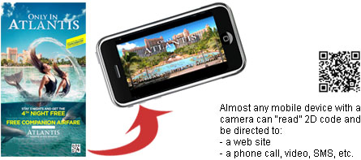
How 2D codes can be useful for marketing?
2D codes can be placed on any printed materials, buildings, soda cans, etc. and provide additional information about offers, coupons, or any company promotions. Most mobile devices with a camera can take a picture of the code and quickly access the info. Some 2D codes are completely free to use. 2D codes benefit both a consumer and a marketer: consumers can reach the information quickly and marketers can measure success of their campaigns.
History of 2D codes
The most popular code – QR code – was invented in Japan; during 90′s all Japanese mobile carriers agreed to include QR reading software into their phones. QR codes can be created by anyone license free and most readers can be downloaded to any camera enabled smart phone for free – http://www.cognation.net/qr/ QR codes are widely used in Japan and are starting to appear in western countries, including the US. There is a range of proprietary systems, which have similar function but require payment.
A few types of 2D codes (US)
QR Code
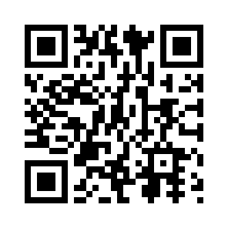 | Scan this Tag to see where it takes you.
How to generate: http://2d-code.co.uk/qr-code-generators
How to download a reader: http://percentmobile.com/getqr (or search for QR reader on your mobile device)
QR code is completely free for use. Success of the promotions can be measured by the traffic generated to the URL, which is easy to do through Web Analytics software. QR code is an open format becoming more popular.
More information on QR code from Bee Tag.
Datamatrix Code
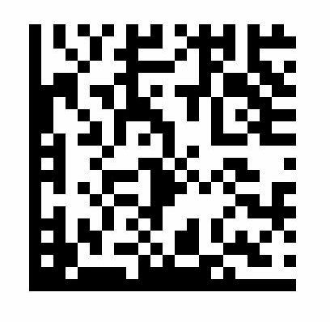 | Scan this Tag to see where it takes you.
Please note, this Datamatrix code was generated with Bee Tag software However, there are other options. Similar to QR code, Datamatrix can be tracked through the traffic it generates to the encoded URL, by using Web Analytics software.
More information on Datamatrix code from Bee Tag.
Microsoft Tag
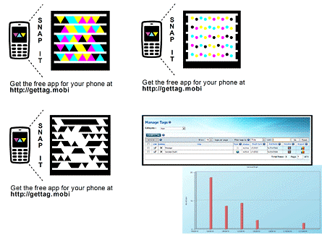 | 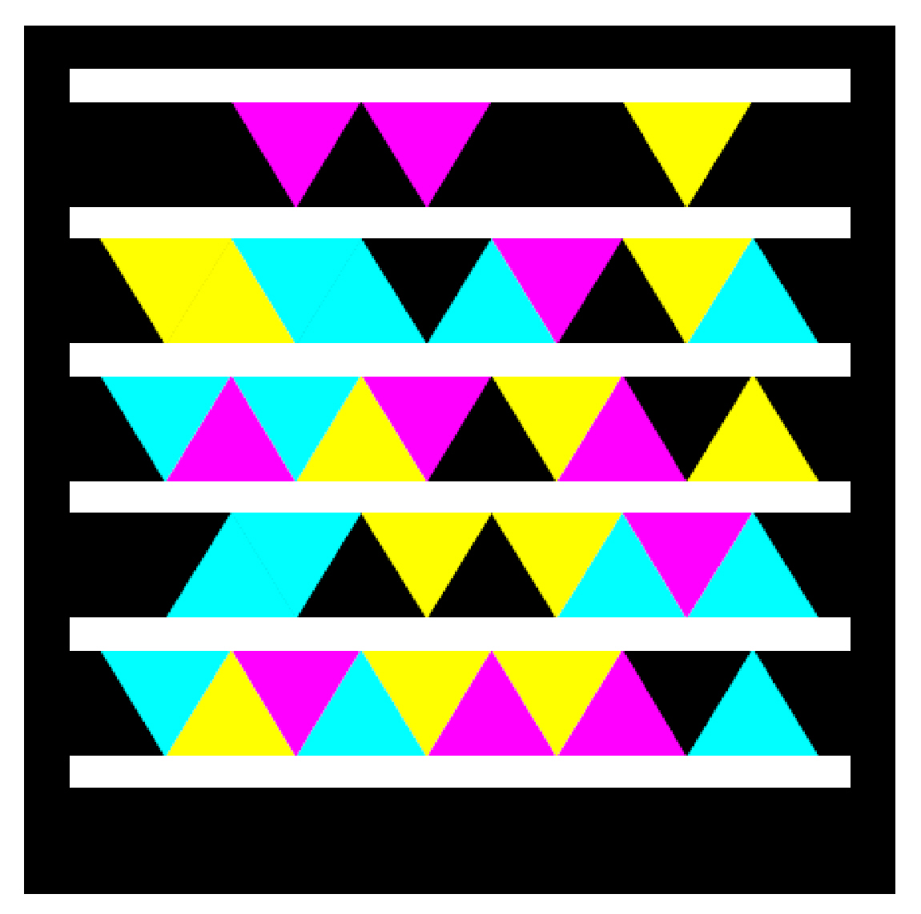
 | Scan this Tag to see where it takes you.
How to generate a tag: http://www.microsoft.com/tag/
How to download a reader: http://gettag.mobi/
Microsoft Tag is a proprietary tag which just celebrated its first anniversary and is currently free to use. Microsoft might decide to charge for the use of the tag in the future, however, everybody who started a free trial will be able to use existing tags free for next two years.
Microsoft tag can be published in a colorful format, black/white, and also in a custom format allowing more creativity for the designers. Microsoft Tag provides an interface for management of all generated tags and tracking consumer activity.
I think Microsoft Tag is pretty (personal opinion ) and it also works surprisingly fast. Microsoft Tag works well in small size. If you are interested, this is a concise technical comparison of Microsoft Tag and QR code.
More information: http://www.microsoft.com/tag/
Bee Tag
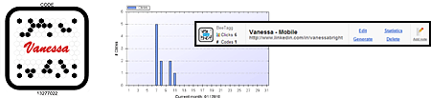
How to generate: http://generator.beetagg.com/
How to download a reader: http://www.beetagg.com/downloadreader/
Bee Tag is another proprietary system allowing businesses to embed their logo into the code. Bee tag has a free version of the software which might show ads before redirecting consumers to the destination of the tag. Bee Tag also has built-in metrics and tag management interface, similar to Microsoft Tag. Bee Tag allows creating and managing Bee Tags, QR code, and Datamatrix in one interface.
More information: http://www.beetagg.com/BeeTaggSystem/BeeTagg.aspx
ScanLife
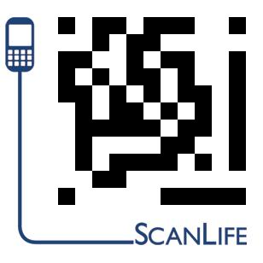 | Scan this Tag to see where it takes you.
How to generate: http://www.scanlife.com/us/services.html
How to download a reader: http://www.scanlife.com/us/appdownload.html
ScanLife offers free service for personal use (limit 1000 codes – quite enough), and paid business solution.
ScanLife site has a great library of examples – very useful for campaign ideas. All examples have a code that can be canned from the computer screen; some of the campaigns and mobile destination sites are still active. You can find different industries and applications – a wonderful resource to review.
More information: http://www.scanlife.com/us/
JagTag
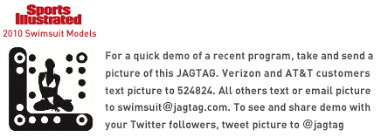
(The demo is copied from http://www.jagtag.com/jagtag-demo)
How to generate: http://www.jagtag.com/ (no free service for generation of functioning code is available)
No reader is needed
JagTag is the only 2D code which does not requires the reader. However, the process of using the code is not as streamlined as applying a reader already present on the mobile device. The consumer needs to take a picture of the 2D code, and then text it or e-mail it to a provided number or an e-mail address. It is rather cumbersome comparing to QR readers (and other 2D code readers), but – true – no initial download is needed.
If we are lucky to see cooperation of mobile companies similar to the cooperation that happened in Japan’s history, all mobile devices will have a standard reader… eventually. Now, JagTag claims to be the only 2D code suitable for US, because no reader is needed.
JagTag site has a good collection of Market Applications with examples of its 2D code. This collection can be used as an inspiration for marketing ideas suitable for QR, Microsoft Tag, Bee Tag, ScanLife and other codes.
What 2D codes can do (more)
- Display text
- Open a web site on the mobile phone
- Initiate e-mail, SMS, phone call
- Start video/audio stream

